City barber closes down after 114 years following row over 'bid to almost double rent'
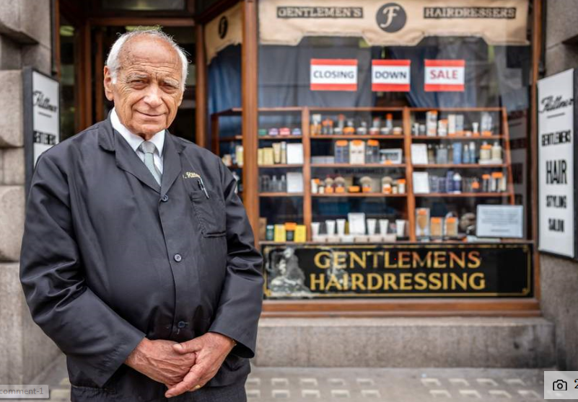
Chris Christodoulou has run the F Flittner barber shop for five decades. The shop itself opened in 1904. (Alex Lentati)
A family-run barber shop that became a Square Mile institution is closing down after 114 years.
Chris Christodoulou, owner of the F Flittner barbershop at 86 Moorgate, bid an emotional farewell to scores of loyal customers yesterday after running the shop for five decades.
The store has the original wood carved Edwardian fixtures, mirrors and glasswork and remains popular with City workers who want a traditional haircut or shave during their lunch hour.
The closure is the culmination of three years of battling the City of London Corporation, which “almost doubled” his rent — until finally backing down.
The shop is listed as part of the Bridge House Estates Charitable Trust and City of London has a legal obligation to achieve market rent on behalf of the trust. Three months ago City of London agreed Mr Christodoulou could remain at the same rent, but he said that by that point he had “had enough” and feared getting into further debt if he continued to run the business.
He said he was “devastated” to make the decision and has been visited by scores of well-wishers.
Mr Christodoulou said: “We are the last of the old shops left, the barber shops have disappeared one by one. We are the only one left and a bit of a Moorgate institution.
“It was only on Bank Holiday Monday I told people I was closing and I’ve spent the last few days explaining to loyal customers I have to shut.” He added: “I decided three months ago I couldn’t take any more. The expense of staying afloat was draining me, so I decided to hand the lease back to the landlords.
“It’s just not sustainable, shops are dropping like flies around here because of high rents.”
The shop opened in 1904 and Mr Christodoulou’s father took over in 1970 until his death three years later. Mr Christodoulou has run it ever since.
“"We are the last of the old shops. The barbers have disappeared one by one. We are a bit of an institution" Chris Christodoulou
Source: London Evening Standard

