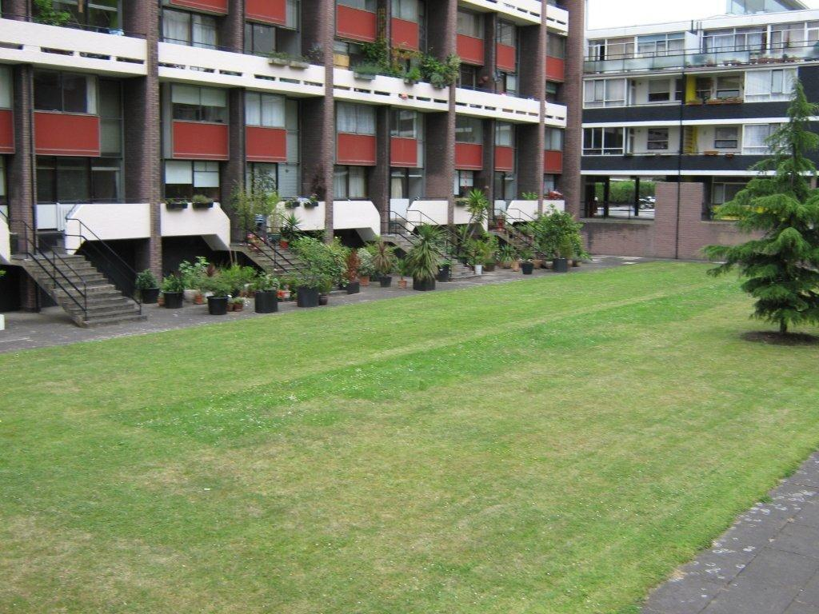

**The Meeting will be chaired by**

**Jacqui Campbell - Head of Housing Management**

**The City of London Housing Services Estate Meeting**

**The Golden Lane Estate**

**Date: 29 July 2014**

**Time: 7.00pm**

**Venue: Sir Ralph Perring Club**